6/8/2022

TCPC/TCQAS

**A Comprehensive Monitoring and Results Framework for the TC Programme**

**Table of Contents**

1. Purpose and Context 3

The Technical Cooperation Programme: Responding to Member State Needs 3

The Global Development Context: Agenda 2030 and the SDGs 3

Results-Based Management of the TC Programme 4

Thematic Areas: The TCP’s Main Areas of Support 4

2. The Foundations of the Framework 4

3. Use of the Framework 6

Mapping of projects and CPFs to Results Framework indicators 6

Increased guidance on Gender 7

Monitoring of project progress and reporting against TC Quality Criteria 7

Lessons Learned emerging from PARs 7

Review of CPFs 7

Thematic plans and corporate initiatives 8

Increased efforts in assessing impact 8

Survey of counterpart institutes and other stakeholders for data on outcomes 8

Strengthening capacities of M&E in Member States 8

Consolidated systems for results reporting 8

Appendix 1: Summary Results Framework 9

Appendix 2: Results Levels Guidance for Alignment 10

Appendix 3: Theory of Change/Logical Results Chain 11

Appendix 4: Enablers and Critical Success Factors for the TC Programme 12

Appendix 5: Nuclear Applications and Technologies 15

# Purpose and Context

In the context of more than 60 years of the Agency’s Technical Cooperation (TC) Programme, the introduction of a results-based management approach is relatively recent – and has evolved rapidly. Progress has been made in moving beyond basic compliance through reporting achievement of activities and outputs, towards monitoring for improved implementation and reporting credibly on outcomes and impact. This shift can be further supported by the adoption and use of a comprehensive Monitoring and Results Framework for the TC Programme (TCP).

In 2015, the TC Senior Management endorsed an Outcome Monitoring (OM) Pilot of 16 projects in the thematic area of human health and nutrition from TCP 2016-2017. The pilot consisted of testing and applying the tools that were in use, to identify efficient and effective approaches for the future. One of the main conclusions of the pilot was that outcome monitoring would eventually need to be applied at an aggregate level instead of addressing individual TC projects, and that it would become necessary to align with elements of CPFs, thematic plans, and the SDGs.

The Comprehensive Monitoring and Results Framework combines the lessons learned from the OM Pilot, OIOS and EA recommendations, and the experience of TC project teams on the use of the results-based management tools and systems in place to design, implement and report on TC projects and CPFs. It builds on the analysis of available data and shifts the focus, from monitoring of progress in the completion of planned outputs of TC projects during the implementation period, to reporting on changes that occurred beyond the implementation time, as a result of the outputs of TC projects. The use of standardised aggregated programmatic indicators provides a basis for TC Programme reporting and for communication with TCP stakeholders about the achievement of expected results and their contribution to higher-level objectives. It also improves the visibility of national and regional development results in Member States, to which the TCP contributed.

## The Technical Cooperation Programme: Responding to Member State Needs

The TCP is the IAEA’s major mechanism for transferring nuclear science and technology and building capacity in Member States. Its goal is to *“increasingly promote tangible socio-economic impact by contributing directly in a cost-effective manner to the achievement of the major sustainable development priorities of each country”,* as stated in the 2002 revision of the 1997 TC Strategy[1]. The TC Strategy remains the principal guiding document for the TCP, together with the IAEA Statute, the Revised Guiding Principles and General Operating Rules to Govern the Provision of Technical Assistance by the Agency, as contained in INFCIRC/267 and relevant RSAs, the IAEA Medium-Term Strategy and directives from the General Conference and the Board of Governors.

## The Global Development Context: Agenda 2030 and the SDGs

The UN General Assembly adopted Resolution 70/1 “The 2030 Agenda for Sustainable Development”[2] in 2015, and soon after 196 countries adopted a new Framework Agreement on Climate Change[3], the Paris Agreement. The Agenda 2030 provides a blueprint for shared prosperity in a sustainable world, where all people can live productive, vibrant, and peaceful lives on a healthy planet[4]. There are 17 Sustainable Development Goals (SDGs) with 169 targets, which together present an interconnected global strategy for transformation. The SDGs acknowledge that sustained systemic change cannot be achieved through single-sector goals and approaches but requires cross-sectoral solutions. SDG 17 highlights the role of science, technology, and innovation as essential enablers for sustainable development. The IAEA MTS 2018-2023 acknowledges that the Agency can expect increased demand from Member States to support their efforts to achieve their national SDG targets through the application of nuclear science and technologies.

## Results-Based Management of the TC Programme

Results-based management of the TC Programme has evolved substantially, including through:

* introduction of the logical framework approach at design;
* adoption of TC Reports as a platform for mandatory annual project progress assessment reports (PPARs);
* introduction of Country Programme Frameworks (CPFs) that include a results matrix;
* mandatory submission of project achievement reports (PARs) for all TC projects before project closure;
* IT platforms such as PCMF, TC Reports and AIPS – where project related data can be found;
* testing of methodologies for assessing impact in various thematic areas and activities.

There is now a high level of basic compliance – and an increasing amount of data – in reporting project-level progress and achievement of activities and outputs of individual TC projects. This provides a base from which to transition towards monitoring results at an aggregate programmatic level and reporting systematically and credibly on outcomes of the TC Programme overall.

## Thematic Areas: The TCP’s Main Areas of Support

The TC Programme is structured around seven distinct but interconnected areas in which the application of nuclear science and technology presently contributes in a concrete and measurable way to the efforts of Member States for the attainment of national development priorities, namely **Health and Nutrition, Food and Agriculture, Industrial Applications, Energy Planning and Nuclear Power, Water and the Environment, Nuclear Knowledge Development and Management, and Nuclear Safety and Security.** The topic of **climate change mitigation and adaptation** is considered a cross-cutting concern that includes a broad range of sectors and thematic areas.

Each thematic sector has intended development results that require the transfer of nuclear technology, recognising the multiple and varied uses of some nuclear techniques. There are interlinkages and interdependencies between them.

# The Foundations of the Framework

The Framework has been developed based on inputs from a variety of sources: the mapping of projects from the past four TCP cycles (2016 to 2023) described below; the assessment of results matrices of CPFs and how they align with TC national project logframes; inputs from the results sub-working group of the TC strategy for the SDGs; recommendations by OIOS and External Auditors; reviews by the TC Technical Advisory Group; and lessons from the annual PPAR/PAR processes and TC Quality Reviews.

The 2002 revision of the TC Strategy highlights the TC central criterion, CPFs, and thematic planning as the principal tools for implementing the TC Programme. The TC central criterion states that TC projects shall produce sustainable benefits in key priority areas where nuclear science and technology have a comparative advantage over other technologies, and which have strong government commitment. Along with CPFs, the TC Programme is guided by [regional strategies/agreements](https://www.iaea.org/about/partnerships/regional/cooperative-agreements), and is intended to be aligned with national sector development plans. The TC Programme is driven by Member States’ needs, responding to their requests in areas where nuclear science and technology can contribute to national development priorities. This Monitoring and Results Framework emerges from these guiding documents and principles, to help answer some key questions:

* What have been the achievements of the TCP?
* In what areas is additional data and analysis required for evidence-based reporting?

The Framework assumes a programmatic approach that positions CPFs, thematic approaches, regional frameworks, or other strategic documents as the platform from which results at the outcome level can be tracked, aggregated, and reported, with the Fields of Activity as the entry point for simplified Theories of Change in each thematic area. The Framework establishes a results-chain that links the TC project logframes with the results matrix of CPFs (and/or thematic approaches where available), and to higher level thematic objectives. This approach is supported by OIOS’s Outcome Monitoring evaluation recommendations.

Many of the fundamental building blocks of the Monitoring and Results Framework have already been developed and are in routine use, such as:

* TC project logframes – reviewed by TCQAS during Quality Reviews;
* CPF results matrices – reviewed by TCSPS;
* Annual PPARs, which provide data on cumulative progress towards planned results;
* AIPS for activity reporting and financial data;
* PCMF/MyTCPride for data on project implementation progress ;
* PARs, which report on achievements and lessons at project closure;
* Impact assessments on thematic areas (RCA).

The Framework is built in an iterative way and will continue to be developed over time. The first step was to agree on the different levels of results planned in TC projects and CPFs; identify which outcomes to report against and select appropriate indicators; and identify the sources of data for monitoring at each level. For TC projects, results data can be drawn from AIPS, PCMF, PPARs and PARs. The intention is to build on this, particularly at outcome level, through targeted surveys to counterparts and other stakeholders. This will enable evidence-based reporting on results and achievements and the use of findings to learn and improve. At impact level, methodologies have been tested by TC, specifically for some RCA thematic areas, and their use will be expanded on demand.

Projects of the past 4 TC Programme cycles, from 2016 to 2023, were mapped to the Agency’s Fields of Activity [5]and thematic areas, as well as planned budget (core and Footnote/a) and SDG alignment. The data shows that, of about 2400 projects included in the portfolio, there are thematic areas where IAEA support has been highly demanded by Member States in recent years, reflecting the needs-based approach of the TC Programme.

This data can help to focus efforts of planning, monitoring, and reporting on the results of the TC Programme, in areas where there is highest demand from Member States, and highest investment of TC resources. In particular, the areas of Safety and Security (22%); Food and Agriculture (23%); and Health and Nutrition (25%) have made up the bulk of the projects requested by Member States in the past 4 TC cycles, as shown in figure 1 below. The remaining projects are spread across the thematic areas of Energy; Industrial Applications; Water and the Environment; and Nuclear Knowledge Management, each representing about 7% of the portfolio.

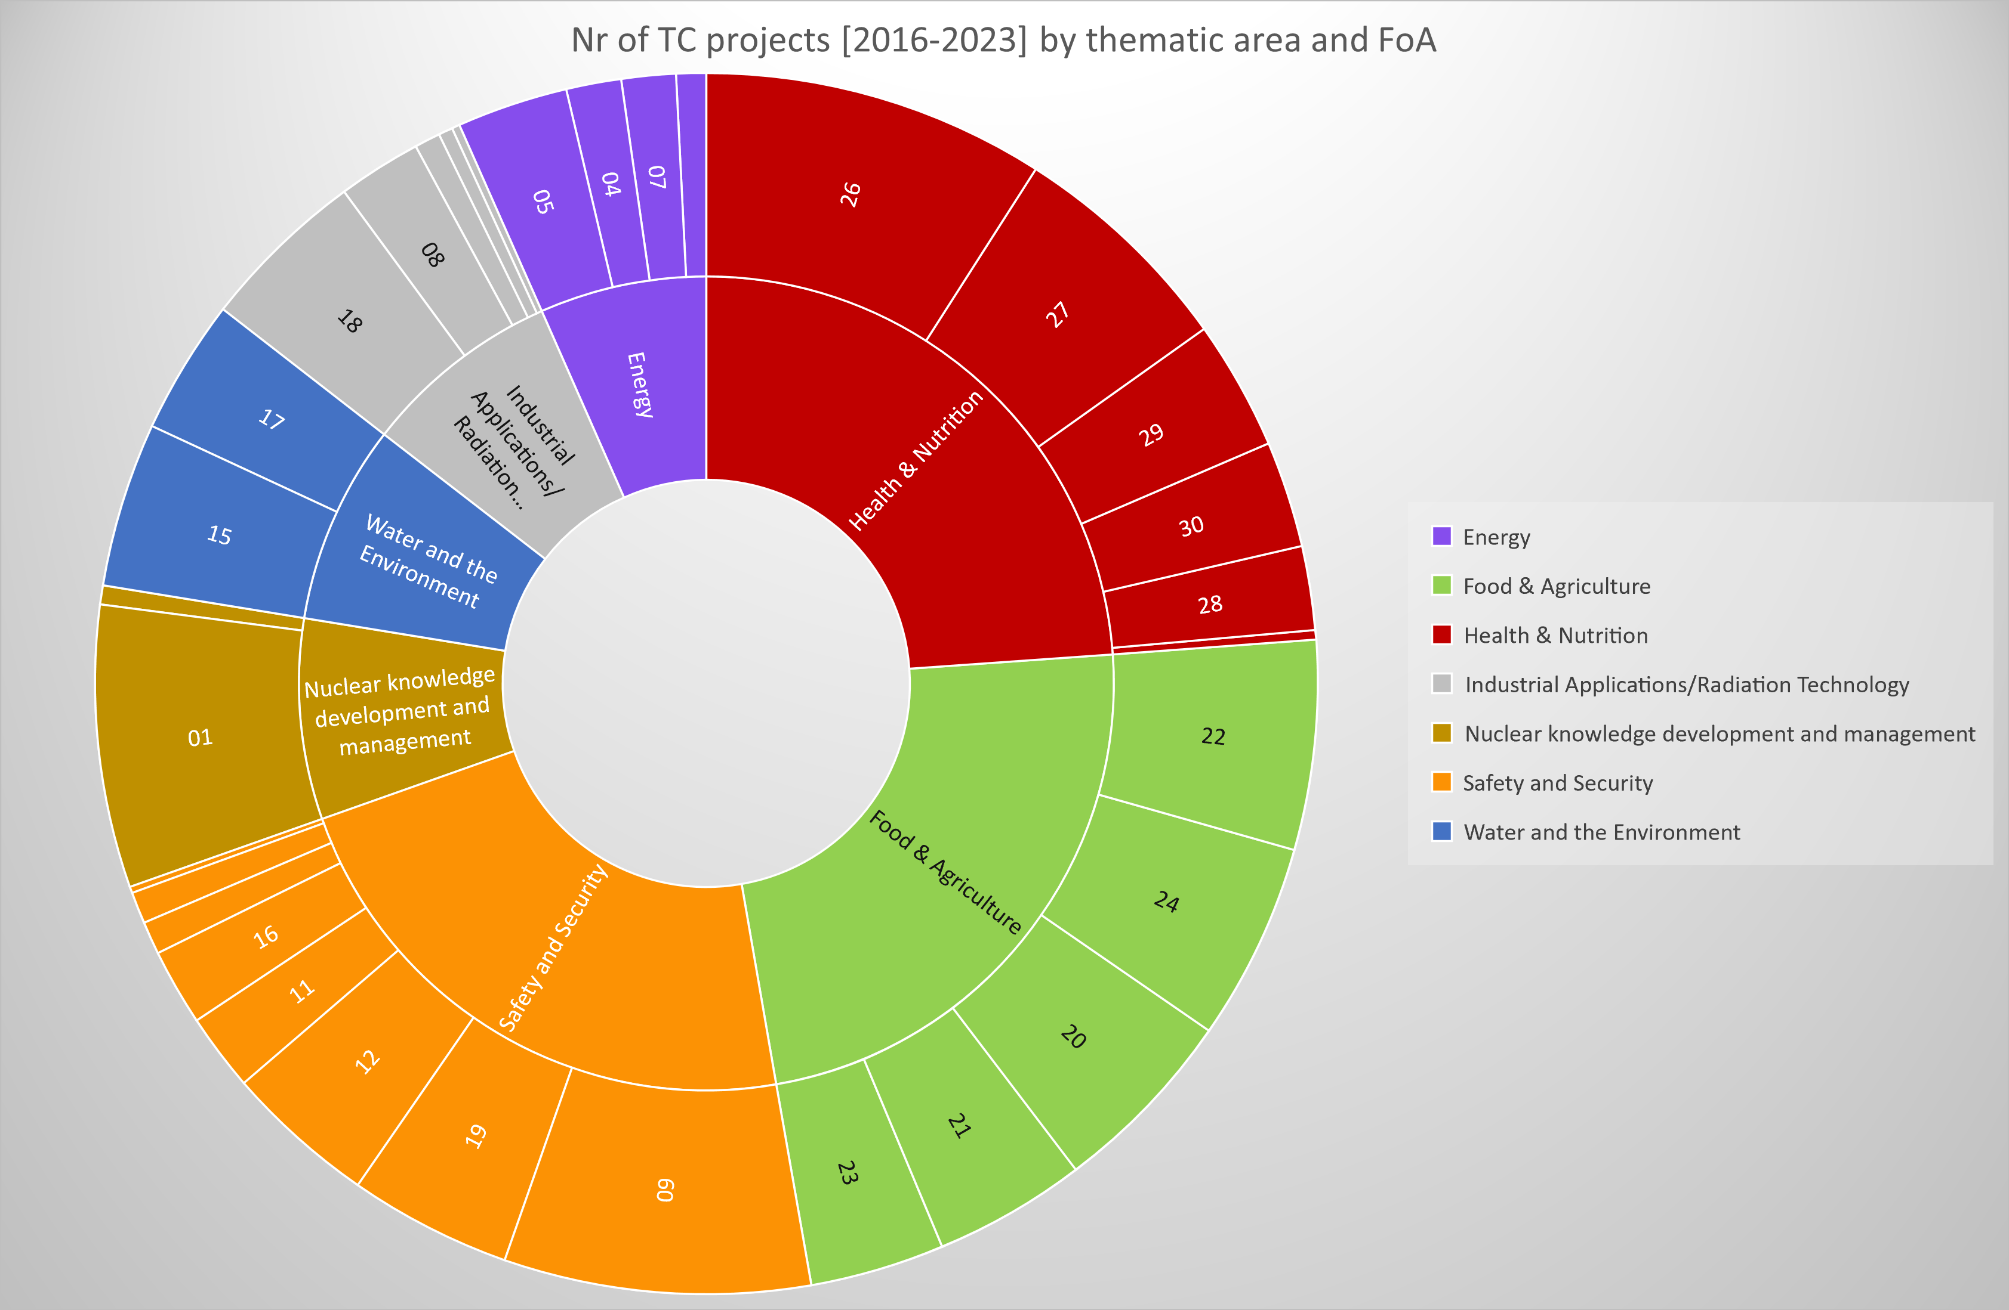

|  |
| --- |
| *Figure 1: TC portfolio over 4 cycles (2016-2023) mapped to thematic areas and FoAs,, by number of projects* |

# Use of the Framework

The Comprehensive Monitoring and Results Framework for the TCP consists of three major pillars:

* A Theory of Change for the TC Programme that establishes connection along the following results chain:

*Nuclear Science and Technology -> TC project inputs (equipment, training, experts) -> TC project outputs -> TC project outcome/CPF output -> CPF Outcome/TC project objective -> Thematic area objective (intended change in MS situation)*

* Defined standardized and aggregated outcome statements for each TC Field of Activity, linked to the Thematic Areas.
* Defined indicators for outputs and outcomes at TC project and CPF levels, respectively, that can be aggregated.

The Monitoring and Results Framework will support and further strengthen a range of prerequisites for robust TCP reporting at the results level and effective communication of the achievements of the TC Programme:

## Mapping of projects and CPFs to Results Framework indicators

The Results Framework will be used by TCPC to map projects and CPFs to the standard aggregated outcome statements. This will not affect individual project logframes and CPFs, which will continue to follow the available guidance during design and planning.

Aggregation by Fields of Activity and thematic area objectives should enable the mapping of a majority of the portfolio, particularly in the most often used Fields of Activity (as shown in the sunburst graph in Figure 1).

To support project teams and increase efficiency of project design and CPF planning, the guidance to project teams was updated for TCP 2024-2025, and a variety of sample logframes and CPF results matrices will be made available to project teams, to provide more clarity on the different levels of results and enhance the alignment between projects and CPFs. Project teams will be able to consult the sample logframes on PCMF and adopt them if appropriate to their project. This will increase efficiency at design and avoid duplication of work during project design and CPF development.

The quality review of TC projects, conducted by TCQAS, will be an opportunity to suggest the use of the sample logframes, and to carry out some of the mapping during design. The quality review also checks alignment with the CPF results matrix.

## Increased guidance on Gender

To guide CPF developers towards the integration of a gender perspective into the CPF in line with the Agency’s Guide on Gender Mainstreaming, some changes to the annotated CPF template have been proposed. A short practical guide for mainstreaming gender into the CPF during the CPF preparation has been prepared by TCSPS. These are being piloted in upcoming CPFs. Data will be gender disaggregated where possible.

## Monitoring of project progress and reporting against TC Quality Criteria

TC projects include logframes that establish indicators with baselines and targets. These are used for reporting in PPARs, which provides data to monitor progress towards achieving the intended results. This data is used in the annual PPAR report for portfolio analysis.

The TC Quality Criteria (based on OECD/DAC Evaluation Criteria) are consistently applied during project design, and later by evaluators. In an effort to strengthen the evaluability of projects, the criteria are now also being introduced to analyse the data emerging from PPARs. The annual PPAR report now includes references about how to conduct a quality assessment process in the monitoring and evaluation phase of TC Cycle. The PPAR and PAR guidance could be updated accordingly to enable the assessment of the TC Quality Criteria in the monitoring and evaluation phase.

## Lessons Learned emerging from PARs

All PARs in the past 4 cycles are being analysed with focus on lessons learned, particularly on management and implementation practices that have been reported by PMOs. This has highlighted the need for some validation of information contained in PARs, and to establish more efficient learning loops in the context of knowledge management. Particular attention will be given to lessons or recommendations regarding the sustainability and/or upscaling of project achievements. The PAR workflow, guidance and template in TC Reports will be reviewed and updated (when resources are available) to make information easier to categorise and search, to be generally more useful for future project teams.

## Review of CPFs

The results matrix in the CPF is still a relatively recent part of the document and is being increasingly adopted by Member States - and the national projects are gradually becoming more aligned to the CPF.  Ideally, the national TC projects should be aligned to the outputs proposed in the CPF results matrix, with suitable indicators. By mapping projects to the standard aggregated indicators in the Results Framework, it will become possible to draw data and conclusions about CPF-level results.

As more MSs adopt the new CPF template with a results matrix, the intention is to introduce an approach for a mid-term review of the CPFs where possible, or a review at the end of a CPF period, to learn from the experience of implementation. Such reviews would inform the priorities for future TC cycles and could focus on transformational assumptions – in other words, the actions that have or need to have taken place for the planned outcomes to be achieved. These would be questioned as part of the survey mentioned below.

## Thematic plans and corporate initiatives

The development of thematic plans (as foreseen in the 2002 Review of the TC Strategy) could make use of the Results Framework – and feed into it – especially for initiatives that encompass more than one FoA and for which standard and aggregated indicators might be useful for design, monitoring and reporting. The same applies to corporate initiatives – particularly those that include a significant TC component to achieve the intended results.

## Increased efforts in assessing impact

The Results Framework is an instrumental element in the effort of assessing TC achievements. Following the mapping of past projects, expected achievements will be verified through a set of surveys, and organized in an evaluative framework following different methodologies tested during the last three years, such as the socio-economic assessment studies developed with for the RCA (TCAP) and the self-evaluation of training activities in TCLAC.

## Survey of counterpart institutes and other stakeholders for data on outcomes

A survey will be prepared by TCPC and sent to all counterpart institutes, for the past and current TC cycles, asking specific and direct questions about results achieved in the different thematic areas, based on the Results Framework and mapping of the portfolio.

The survey results can be used to:

* validate the Theory of Change for each Thematic Area;
* identify areas of achievement for reporting to stakeholders on a regular basis;
* identify gaps in the data, for targeted studies or self-evaluations;
* identify stakeholders downstream of TC projects (e.g. agricultural extension services; sectoral Ministries) who may make use of TC-generated studies and data for decision making;
* data visualisation for better communication and outreach on achievements and results;
* as an input into reviews of CPFs.

## Strengthening capacities of M&E in Member States

Further to the annual reporting by project counterparts on project progress and achievements, capacities will be enhanced in each Member State (National Liaison Officers and Counterparts) to monitor and report on their portfolios and identify/support problem projects, which will increase self-reliance and sustainability. Enhanced monitoring means more informed adjustments during project implementation, leading to improved effectiveness and efficiency, as well as better planning for future projects.

## Consolidated systems for results reporting

The TC Programme planning and design processes are conducted through the Programme Cycle Management Framework (PCMF), while implementation is supported by AIPS, and reporting is done on the TC-Reports platform. The systems reinforce Member States’ responsibility and ownership over the formulation and execution of their national programmes, while allowing stakeholders in the Secretariat to support the process and collaborate within project teams.

Annual progress reporting by individual projects during implementation and achievement reports is done on the TC-Reports platform. Improved reporting functionalities will be required to make better use of quantitative information on results achieved, for portfolio analysis.

Effective inter-connectivity between planning, implementation, and reporting tools (PCMF, AIPS and TC Reports), and with the other IT systems used, will be crucial for enhancing the results focus of the TC Programme. Dashboards, combining data derived from different sources, will be developed to enable reporting on the achievements of the TC Programme and IAEA initiatives to which TC contributes.

# Appendix 1: Summary Results Framework: thematic objectives and levels of results aggregation from CPFs and TC projects

|  |  |  |  |  |  |  |  |  |  |  |  |  |  |  |  |  |  |  |  |  |  |  |  |  |  |  |  |  |  |  |  |  |  |  |  |  |  |  |  |  |  |  |  |  |  |  |  |  |  |  |  |  |  |  |  |  |  |  |  |  |  |  |  |  |  |  |  |  |  |  |  |  |  |  |  |  |  |  |  |  |  |  |  |  |  |  |  |  |  |  |  |  |  |  |  |  |  |  |  |  |  |  |  |  |  |  |  |  |  |  |  |  |  |  |  |  |  |  |  |  |  |  |  |  |  |  |  |  |  |  |  |  |  |  |  |  |  |  |  |  |  |  |  |  |  |  |  |  |  |  |  |  |  |  |  |  |  |  |  |  |  |  |  |  |  |  |  |  |  |  |  |  |  |  |  |  |  |  |  |  |  |  |  |  |  |  |  |  |  |  |  |  |
| --- | --- | --- | --- | --- | --- | --- | --- | --- | --- | --- | --- | --- | --- | --- | --- | --- | --- | --- | --- | --- | --- | --- | --- | --- | --- | --- | --- | --- | --- | --- | --- | --- | --- | --- | --- | --- | --- | --- | --- | --- | --- | --- | --- | --- | --- | --- | --- | --- | --- | --- | --- | --- | --- | --- | --- | --- | --- | --- | --- | --- | --- | --- | --- | --- | --- | --- | --- | --- | --- | --- | --- | --- | --- | --- | --- | --- | --- | --- | --- | --- | --- | --- | --- | --- | --- | --- | --- | --- | --- | --- | --- | --- | --- | --- | --- | --- | --- | --- | --- | --- | --- | --- | --- | --- | --- | --- | --- | --- | --- | --- | --- | --- | --- | --- | --- | --- | --- | --- | --- | --- | --- | --- | --- | --- | --- | --- | --- | --- | --- | --- | --- | --- | --- | --- | --- | --- | --- | --- | --- | --- | --- | --- | --- | --- | --- | --- | --- | --- | --- | --- | --- | --- | --- | --- | --- | --- | --- | --- | --- | --- | --- | --- | --- | --- | --- | --- | --- | --- | --- | --- | --- | --- | --- | --- | --- | --- | --- | --- | --- | --- | --- | --- | --- | --- | --- | --- | --- | --- | --- | --- | --- | --- |
| |  |  |  |  |  |  |  |  |  |  |  |  | | --- | --- | --- | --- | --- | --- | --- | --- | --- | --- | --- | --- | | **TCP RESULTS AREAS (CROSS-CUTTING: CLIMATE CHANGE AND ADAPTATION)** | | | | | | | | | | | | | **FOOD and AGRICULTURE** | **HEALTH and NUTRITION** | | | **ENERGY PLANNING and NUCLEAR POWER** | | **INDUSTRIAL APPLICATIONS and RADIATION TECHNOLOGY** | | **WATER and ENVIRONMENT** | **NUCLEAR SAFETY AND SECURITY** | | **NUCLEAR KNOWLEDGE DEVELOPMENT and MANAGEMENT** | | **TCP OBJECTIVES: Aggregated by FoA (IMPACT)** | | | | | | | | | | | | | Increase sustainable crop and livestock productivity and improve climate resilience in agriculture | Improve comprehensive control, diagnosis, and treatment of cancer and other NCDs, including dosimetry quality control | | | Improve energy planning and inform policies to meet future energy needs | | Improve efficiency, productivity, quality, and safety across industries, using nuclear technologies | | Improve integrated, sustainable, land and water management practices for agriculture and freshwater resources | Establish or enhanced governmental and regulatory infrastructure to ensure radiation safety and security | | Improve capacity, programme knowledge management and facilitation of cooperation among Member States | | Improve food authenticity, quality and reduce contaminants and residues in the food supply | Increase production and use of safe radioisotopes and radiopharmaceuticals to be used in medical applications | | | Support clean energy production & safe introduction, operation, and lifetime management of nuclear power | | Increase the safe and effective utilization, operation, and maintenance of research reactors | | Improve management and reduce pollution of land, air, coastal ecosystems, and the oceans, including from plastics | Improve radiation protection of workers, patients, and the public | | Enhance legal infrastructures, in line with international legal instruments, as well as with the IAEA safety standards | | Improve surveillance, detection, and control of major insect pests of Agricultural, Veterinary and Human importance, including emerging or re-emerging zoonotic diseases | Increase effectiveness of nutrition programmes interventions and practices | | |  | | Improved quality, reliability and comparability of measurement results obtained by radioisotopes techniques and safe use of nuclear instrumentation | |  | Improve sustainable management of radioactive waste, transport safety, and emergency preparedness & response | |  | | **APPLIED NUCLEAR TECHNOLOGIES (FoAs)** | | | | | | | | | | | | | 20 Mutation breeding  21 Agricultural water and soil management  22 Livestock production  23 Insect pest control  24 Food safety | 25 cancer control  26 radiation oncology  27 Nuclear medicine  28 Radioisotopes & radio pharma  29 dosimetry & medical physics  30 Nutrition for improved health | | | 4 Energy planning  5 Introduction of nuclear power  6 Nuclear power reactors  7 Nuclear fuel cycle | | 2 Reference products for science and trade  8 Research reactors  18 Radioisotopes and radiation technology applications  32 Accelerator technology  33-Nuclear Instrumentation | | 15 Water resources management  17 Marine, terrestrial and coastal environments | 9/11 Gov/reg infrastructure for radiation/nuclear installations safety  10 Safety of nuclear installations  12 Radiation protection workers/public  13 Transport safety/ 14 Nuclear security  16 Emergency preparedness/response  19 Radioactive waste management  31 - Radiation protection | | 01 Capacity building and KM  03 Nuclear legal infrastructure | | **TCP OUTCOMES: Aggregated from CPFs and Regional Frameworks (USE OF ESTABLISHED CAPACITY)** | | | | | | | | | | | | | Adoption of plans, policies, programmes, or technical standards by national entities | | Increased use of a tool, technique, or technology in a sector | | | Establishment of a new institution, laboratory, education centre, etc. | | | Production and use of data of knowledge through use of a tool or technique | | Workforce skill improvement (not directly trained through TC) | | | **TCP PROJECT OUTCOMES/CPF OUTPUTS: Aggregated from TC Projects and CPFs (CAPACITY INCREASED)** | | | | | | | | | | | | | Increased analytical/regulatory capacities | | Capacities strengthened | | | Institutions/laboratories strengthened | | | Increased understanding / Data created/disseminated | | Increased professionalization of workforce | | | **TCP OUTPUTS: Aggregated from TC Projects (DELIVERABLE)** | | | | | | | | | | | | | Expert advice and support on plans, policies, programmes, or technical standards provided | | | Equipment procured, training delivered, and relevant guidelines developed | | | | New protocols/guidelines introduced | | Long term training of specialists  and development of study curricula delivered | | | | **TCP INPUTS: Aggregated from TC Projects** | | | | | | | | | | | | | Expert Missions | | | Procurement | | | | Fellowships/Scientific Visits | | Training Meetings/Workshops | | | |

**Appendix 2: Results Levels Guidance for Alignment**

This table shows the proposed levels of aggregation at the different results levels, as well as the data sources to enable reporting at each level.

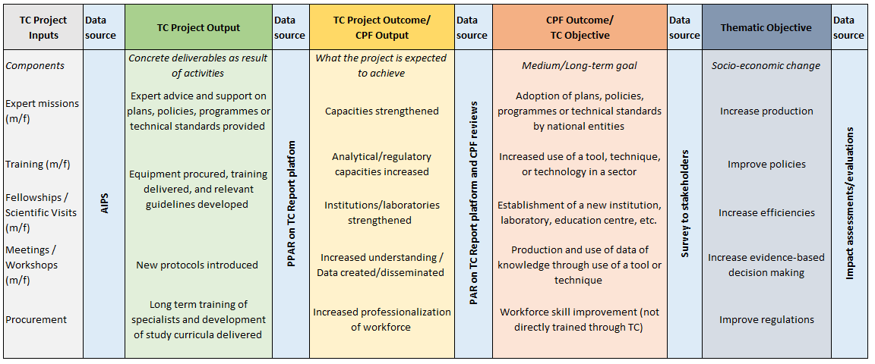

# Appendix 3: Theory of Change/Logical Results Chain

## 

**How nuclear technology and TC projects contribute to socio-economic development**

The TCP is the IAEA’s primary mechanism for building the capacity of Member States in the peaceful, safe, and secure use of nuclear science and technology across a range of sectors. The TCP is based on Member States’ needs and priorities and on the principle of shared responsibility between Member States and the Secretariat, with the lead role taken by the Member States. The IAEA Department of Technical Cooperation manages the TCP, with the Technical Departments providing technical backstopping.

The dissemination and transfer of nuclear science and technology through the TCP takes place primarily through capacity building and the provision of equipment, underpinned by the Agency’s technical expertise, information networks, and safety standards and security guidance. The knowledge and technology are transferred through national, regional, and interregional technical cooperation projects which are designed, jointly implemented, and monitored following the results-based management approach.

The Theory of Change demonstrates the connection and causal relationship between activities conducted in the framework of TC projects and intended changes at country or institutional levels, and hence their contribution to socio-economic impact. Figure 3 illustrates this results chain, along with the key role played by partners in ensuring the scaling-up and sustainability of results.

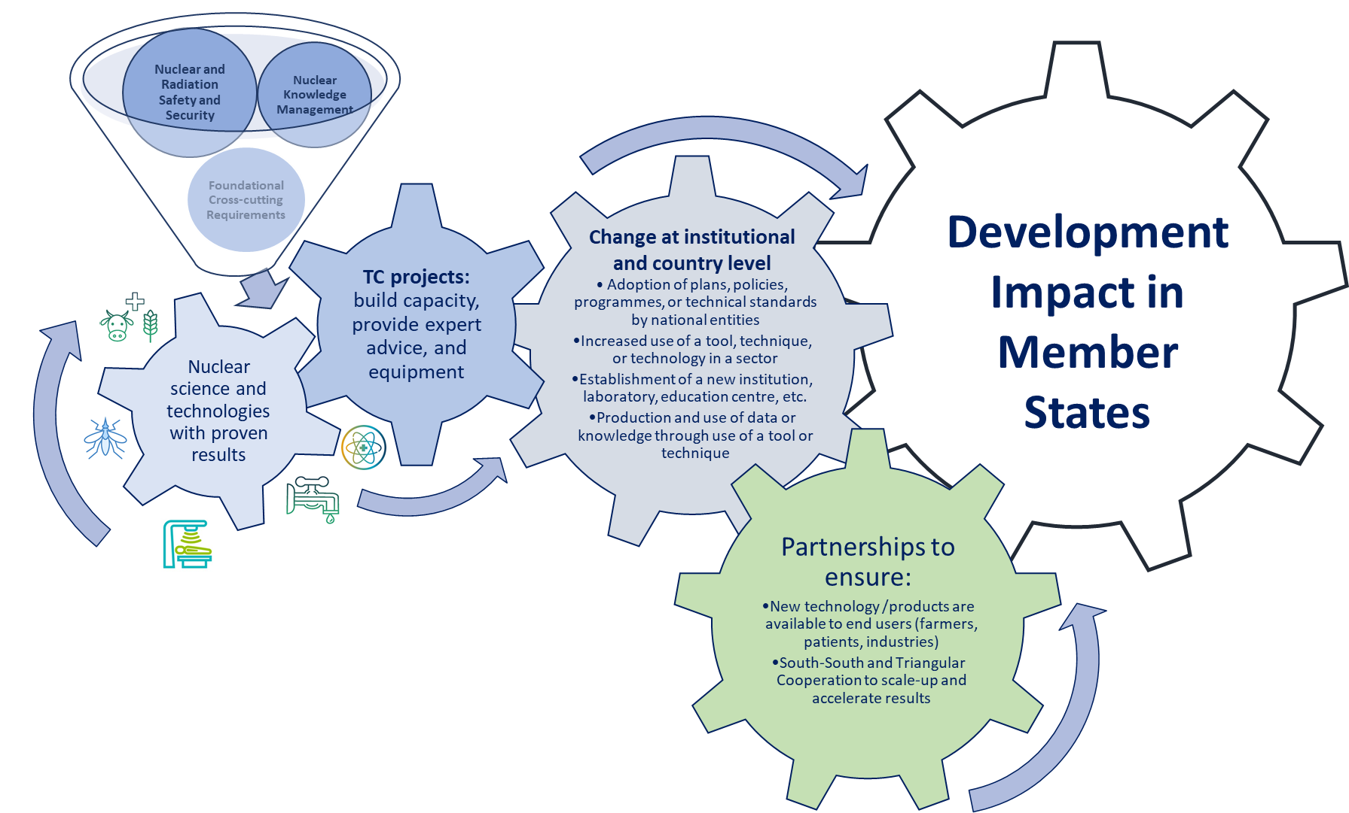

Figure 3: The logical results chain linking nuclear science, TC projects and impact in Member States.

# Appendix 4: Enablers and Critical Success Factors for the TC Programme

**Tools for increasing implementation effectiveness and efficiency, and measuring impact**

To deliver a more efficient and effective TCP, several enablers and critical success factors need to be in place, which will guide the overall focus and management of the TCP. **The tools and systems currently in use will need to be updated, and new approaches adopted, some of which are described here.**

**Country Programme Frameworks**

A Country Programme Framework is a strategic programming tool guiding the technical cooperation between a Member State and the IAEA during a period of four to six years. Country-specific analyses ensure that the use of nuclear technologies responds to national development priorities through the identification of areas where such technologies can be usefully deployed. CPFs are aligned with national development plans and/or relevant sectoral strategies and policies, the SDGs, the United Nations Sustainable Development Cooperation Framework (UNSDCF), as well as other relevant regional and global frameworks and agreements.

The TCP will continue efforts to increase the number of Member States with CPFs, including support to align the proposed TC support with the Member State’s SDG targets. Future CPFs would adopt indicators stated in the proposed TC Results Framework to facilitate the linking between TC projects and the country portfolio and aggregation of results.

**Regional strategic frameworks and South-South and Triangular Cooperation**

South-South and triangular cooperation play an important role in supporting strong partnerships and learning between Member States. These partnerships enable the sharing of nuclear knowledge, expertise and technology and enhance the impact and sustainability of the IAEA’s contribution to sustainable development. The TCP will accelerate efforts to expand the use of mechanisms, tools, and networks for South-South and triangular cooperation towards the achievements of nationally identified targets. Results towards achievement of national and regional priorities will be magnified and sustained by close collaboration and support to regional networks, agreements, and initiatives.

The Regional Cooperative Agreements are important mechanisms to support South-South and triangular cooperation. The IAEA has concluded four such Agreements, with the aim of strengthening and enhancing the contribution of nuclear science and technology to sustainable development in Africa, Latin America and the Caribbean, Asia and the Pacific, and Arab States in Asia. While each agreement functions under specific modalities, all four share a general focus on strengthening capacities, sharing knowledge, resources, and best practices among their members, and promoting sustainability and collaboration among the diverse actors using or associated with nuclear science and technology. With the support of the IAEA, a number of regional networks have been set up under each of these agreements, such as the African Food Security Network (AFoSaN), the Food Safety Asia Network, the Veterinary Diagnostic Laboratory (VETLAB) network.

**Thematic planning and flagship initiatives**

Thematic planning is a process by which specific thematic areas are identified for which the transfer of proven nuclear technology and well-established knowledge, through technical cooperation, can be expected to result in significant and sustainable impact. It helps to define priorities and identify opportunities for raising awareness of new or existing nuclear applications or research, for which Member States may request TCP support.

Nuclear technologies that have been developed and undergone rigorous validation through IAEA’s research activities can then be transferred to countries upon request, especially to developing Member States, through the TCP, to address development priorities. This is illustrated in Figure 6 below. The IAEA has established corporate flagship programmes, initiatives and thematic approaches that highlight the multidisciplinary application of nuclear technologies, foster partnerships and build on integrated, larger-scale programming. Initiatives such as Zodiac, NUTEC Plastics, Rays of Hope, food safety, and climate change, highlight the strength of a thematic approach.

The TCP will place increased focus on identifying and advancing flagship projects and initiative in support of selected priorities, through the framework of thematic planning.

Figure : The IAEA process for transferring R&D results to Member States through the TCP.

Individual research in laboratories

Testing and validating of R&D

Research results published

Dissemination of technology

TC projects for technology transfer

Policies and investments

Validation of R&D through other/ external processes

IAEA Laboratories   
Collaborating Centres

Coordinated Research

Technical Cooperation

New research needs to be identified through RB activities

New/additional testing and validation needs to be identified through TC Projects

New research needs to be identified and capacity built through TC Projects

**Partnerships**

Partnerships and collaborative relationships are critical to delivering results, ensuring the continued provision of high-quality services and maximising impact to the benefit of Member States.

The IAEA does not have country offices in its Member States. Support is provided from headquarters and its research laboratories at Seibersdorf (Austria) and in Monaco, and through National Liaison Officers – the IAEA’s primary contact persons in a Member State for the TCP. Key partners in addition to the Member States include other UN agencies, international organizations, national and international research organizations, universities, foundations, international financial institutions, development banks, regional organizations, and the private sector.

A broad range of different mechanisms support the identification, building and strengthening of partnerships and collaborative relationships for achieving strategic, programmatic and/or operational objectives. These include written agreements (e.g. Practical Arrangements, Memoranda of Understanding, Contribution Agreements), the IAEA’s regional networks, Collaborating Centres, regional and national resource institutions and designated institutions around the world, and the South South and Triangular Cooperation modality. Increasing the visibility of national and regional results achieved through the support of the TCP also serves to accelerate the uptake by potential partners.

The IAEA TC programme will expand effective partnerships in line with its rules and regulations by:

* enhancing communication and outreach to improve awareness among relevant stakeholders of the contributions of nuclear science and technologies to development priorities;
* continuing efforts to build and strengthen partnerships with traditional partners;
* identifying and building partnerships with relevant non-traditional partners, including the private sector, and international financial institutions; and
* exploring relevant financing models, including deriving from the 2030 Agenda financial architecture.

International financial institutions act as catalysers for financial resources and support, for example, health system development, hospital building and equipment acquisition, and human capital development. Global health and education are often high priority areas of support for development banks and therefore serve as a possible avenue for resources and knowledge sharing.

The aim of partnering with the *private sector* is to leverage their expertise to support Member States’ national development strategies and plans. Corporate partnerships can combine technical assistance, knowledge transfer and financial contributions from industry that can strengthen TCP implementation, while helping to amplify and raise awareness of the TCP. Thus, partnering with the private sector can add significant value to the private sector’s focus on corporate social responsibility while at the same time supporting the upscaling of technology outputs of the TCP.

**Capacity building and emergency response**

The TCP will continue to support Member States in responding to emergencies through the use of nuclear science and technology, for example in the case of natural disasters (earthquakes, floods) and disease outbreaks (Ebola, Zika, COVID-19), as well as nuclear or radiological accidents. The ability to respond flexibly will be maintained, with a focus on building resilience where Member States foresee a need, for example in response to climate change.

The TCP will continue to support Member States in their efforts to enhance their technology-based capabilities to address their national development priorities using nuclear technologies through different types of training and education, including e-learning. Capacities will be built in an integrated manner and aligned with relevant partners, including universities and nuclear research institutes, as well as the IAEA Collaborating Centres and regional training centres in Member States. Using synergies with other tools for tailor made result-oriented support, such as Integrated Work Plans in the field of nuclear infrastructure development.

**Scale up financing for the TC Programme**

The TCP is funded by the *Technical Cooperation Fund (TCF),* extrabudgetary contributions (including funding where the donor is the recipient) and in-kind contributions. *Extrabudgetary contributions* are predominantly made by ‘traditional’ donors, are earmarked to specific projects and often leverage resource mobilisation initiatives such as the Agency’s Peaceful Uses Initiative (PUI)[6] .

Financial resources that flow alongside IAEA funds to a given project or programme are often referred to as *parallel financing*. These resources do not flow through IAEA accounts: activities or components of a specific project are separately financed by the IAEA and a given partner. One way in which the IAEA is leveraging parallel financing is through the support provided by the IAEA to Member States in preparing detailed techno-economic feasibility studies (commonly referred to as “bankable documents”) for a particular project or programme which typically contain all the essential information to allow a financing entity to make an informed risk assessment and take a financing decision. In this regard, the IAEA acts as a technical advisor and facilitator to ensure Member States develop bankable documents that are technically sound, financially viable and that enable them to secure substantial resources from investors.

While traditional channels for development assistance focus on the needs of partners countries through country-based, so-called horizontal funding allocations, *thematic and vertical funds* are global programmes for allocating official development assistance that focuses specifically on an issue or theme,. This has become increasingly popular over the last 30 years, driven by funding allocated to health and climate-related entities.[7] Some relevant funds include the Global Environment Facility, the Green Climate Fund, and the Global Fund to fight AIDS, Tuberculosis and Malaria. The IAEA will strengthen efforts to support Member States in the identification of complementary global and regional financial mechanisms to mobilise resources for technical cooperation activities contributing to nationally identified priorities.

# Appendix 5: Nuclear Applications and Technologies

There are many applications of nuclear science and technology, which are the basis for all IAEA support to Member States through the TCP. A small selection is presented here.

**Radiotherapy** is one of the most widely used therapies for cancer treatment, consisting of using radiation in its different forms (X-rays, Gamma rays, particles) to destroy tumours.

**Radiology** uses diagnostic imaging techniques (e.g. Computed Tomography and radiography, Positron Emission Tomography and Single-Photon Emission Computed Tomography) based on various forms of radiation. Diagnostic radiology plays an important role in the screening, staging, follow-up, therapy planning, evaluation of therapy response and long-term surveillance of patients.

In **nutrition studies,** isotopic techniques are used to improve the specificity, sensitivity, and accuracy of nutritional evaluations, such as in the assessment of body composition, bone mineral density, total daily energy expenditure, intake of human milk in breastfed infants, vitamin A status, and bioavailability of micronutrients and proteins from foods.

**Mutation** **breeding for crop production** uses irradiation to induce mutations in plants, to produce varieties that display improved product quality, have higher yields and yield stability, greater resilience to climate change and tolerance to environmental stresses. Using ionizing radiation can increase the natural mutation rate in a cost effective, rapid, and safe manner.

The **sterile insect technique** is among the most environment-friendly insect pest control methods ever developed. It involves mass-rearing and sterilization of insects, using Gamma ray and X-ray irradiation, followed by the systematic area-wide release of the sterile males over defined areas, where they mate with wild females resulting in no offspring and a declining pest population.

**Isotopic techniques for sustainable water management** in agriculture, for drinking water, and to monitor ocean pollution - tracking the movement of water through the hydrological cycle, to trace the original source of groundwater, and examine mixing processes within components of the hydrological cycle (precipitation, surface water, groundwater). Nuclear technologies, such as isotopic age determination, radiotracer applications to assess biological stress from diverse contaminants, or forensic source tracking, provide useful insights into the consequences of the impacts of climate and ocean change on marine ecosystems and coastal structures.

**Energy planning tools and assessments** are fundamental elements for independent national energy strategy development. Computer-assisted modelling forms the core of the IAEA approach to assist MSs in their energy analysis and planning. National economic and energy statistics are used to calibrate the models to accurately reflect the current energy system as well as its interaction with the principal drivers of energy demand and supply, such as demographics, economic development, technology change, environment policy and climate objectives.

**Support to countries embarking on or expanding, a safe and secure nuclear power programme**: Assistance is provided using the IAEA ‘Milestones’ approach, a comprehensive methodology that guides countries and organizations to work in a systematic way towards the safe and secure introduction of nuclear power.

**Capacity Building on Small Modular Reactors and Microreactors,** and their technology and applications, as a contribution of nuclear power to the mitigation of climate change.

**Non-destructive testing** is used in industry to evaluate the integrity and properties of material or components without causing damage to the tested object. It is a tool for quality control, safety, reliability, identifying illicit trafficking, preservation of cultural heritage, and optimization of industrial processes.

**Production and quality of radiopharmaceuticals** for healthcare, instilling good manufacturing practices and international quality-assurance standards to protect patients by ensuring that the pharmaceuticals produced are of a high quality, safe and effective. Radiopharmaceuticals contain small amounts of radioisotopes that are tagged on to certain molecules based on biological characteristics to be used as diagnostic or therapeutic agents.

1. GOV/INF/2002/8/Mod.1, [The Technical Cooperation Strategy: The 2002 Review](https://govatom.iaea.org/GovAtom%20Documents/2002/gov-inf-2002-08-mod-1/ginf2002-8mod1_en.pdf).
2. A/RES/70/1 (<http://www.un.org/en/ga/search/view_doc.asp?symbol=A/RES/70/1>)
3. FCCC/CP/2015/10/Add.1 (<http://unfccc.int/files/home/application/pdf/paris_agreement.pdf>)
4. [The Sustainable Development Goals Report 2019](https://unstats.un.org/sdgs/report/2019/)
5. Each project was mapped to only 1 FoA, although many projects are designed to include several. The mapping is meant to highlight some high-level trends for analysis, rather than reflect the granularity of the portfolio.
6. The PUI was established in 2010 to facilitate extrabudgetary contributions to support unfunded IAEA peaceful uses activities, including unfunded technical cooperation projects (footnote a/ projects).
7. OECD. Multilateral Development Finance 2020. Funding to the multilateral development system. https://www.oecd-ilibrary.org/sites/f278439a-en/index.html?itemId=/content/component/f278439a-en